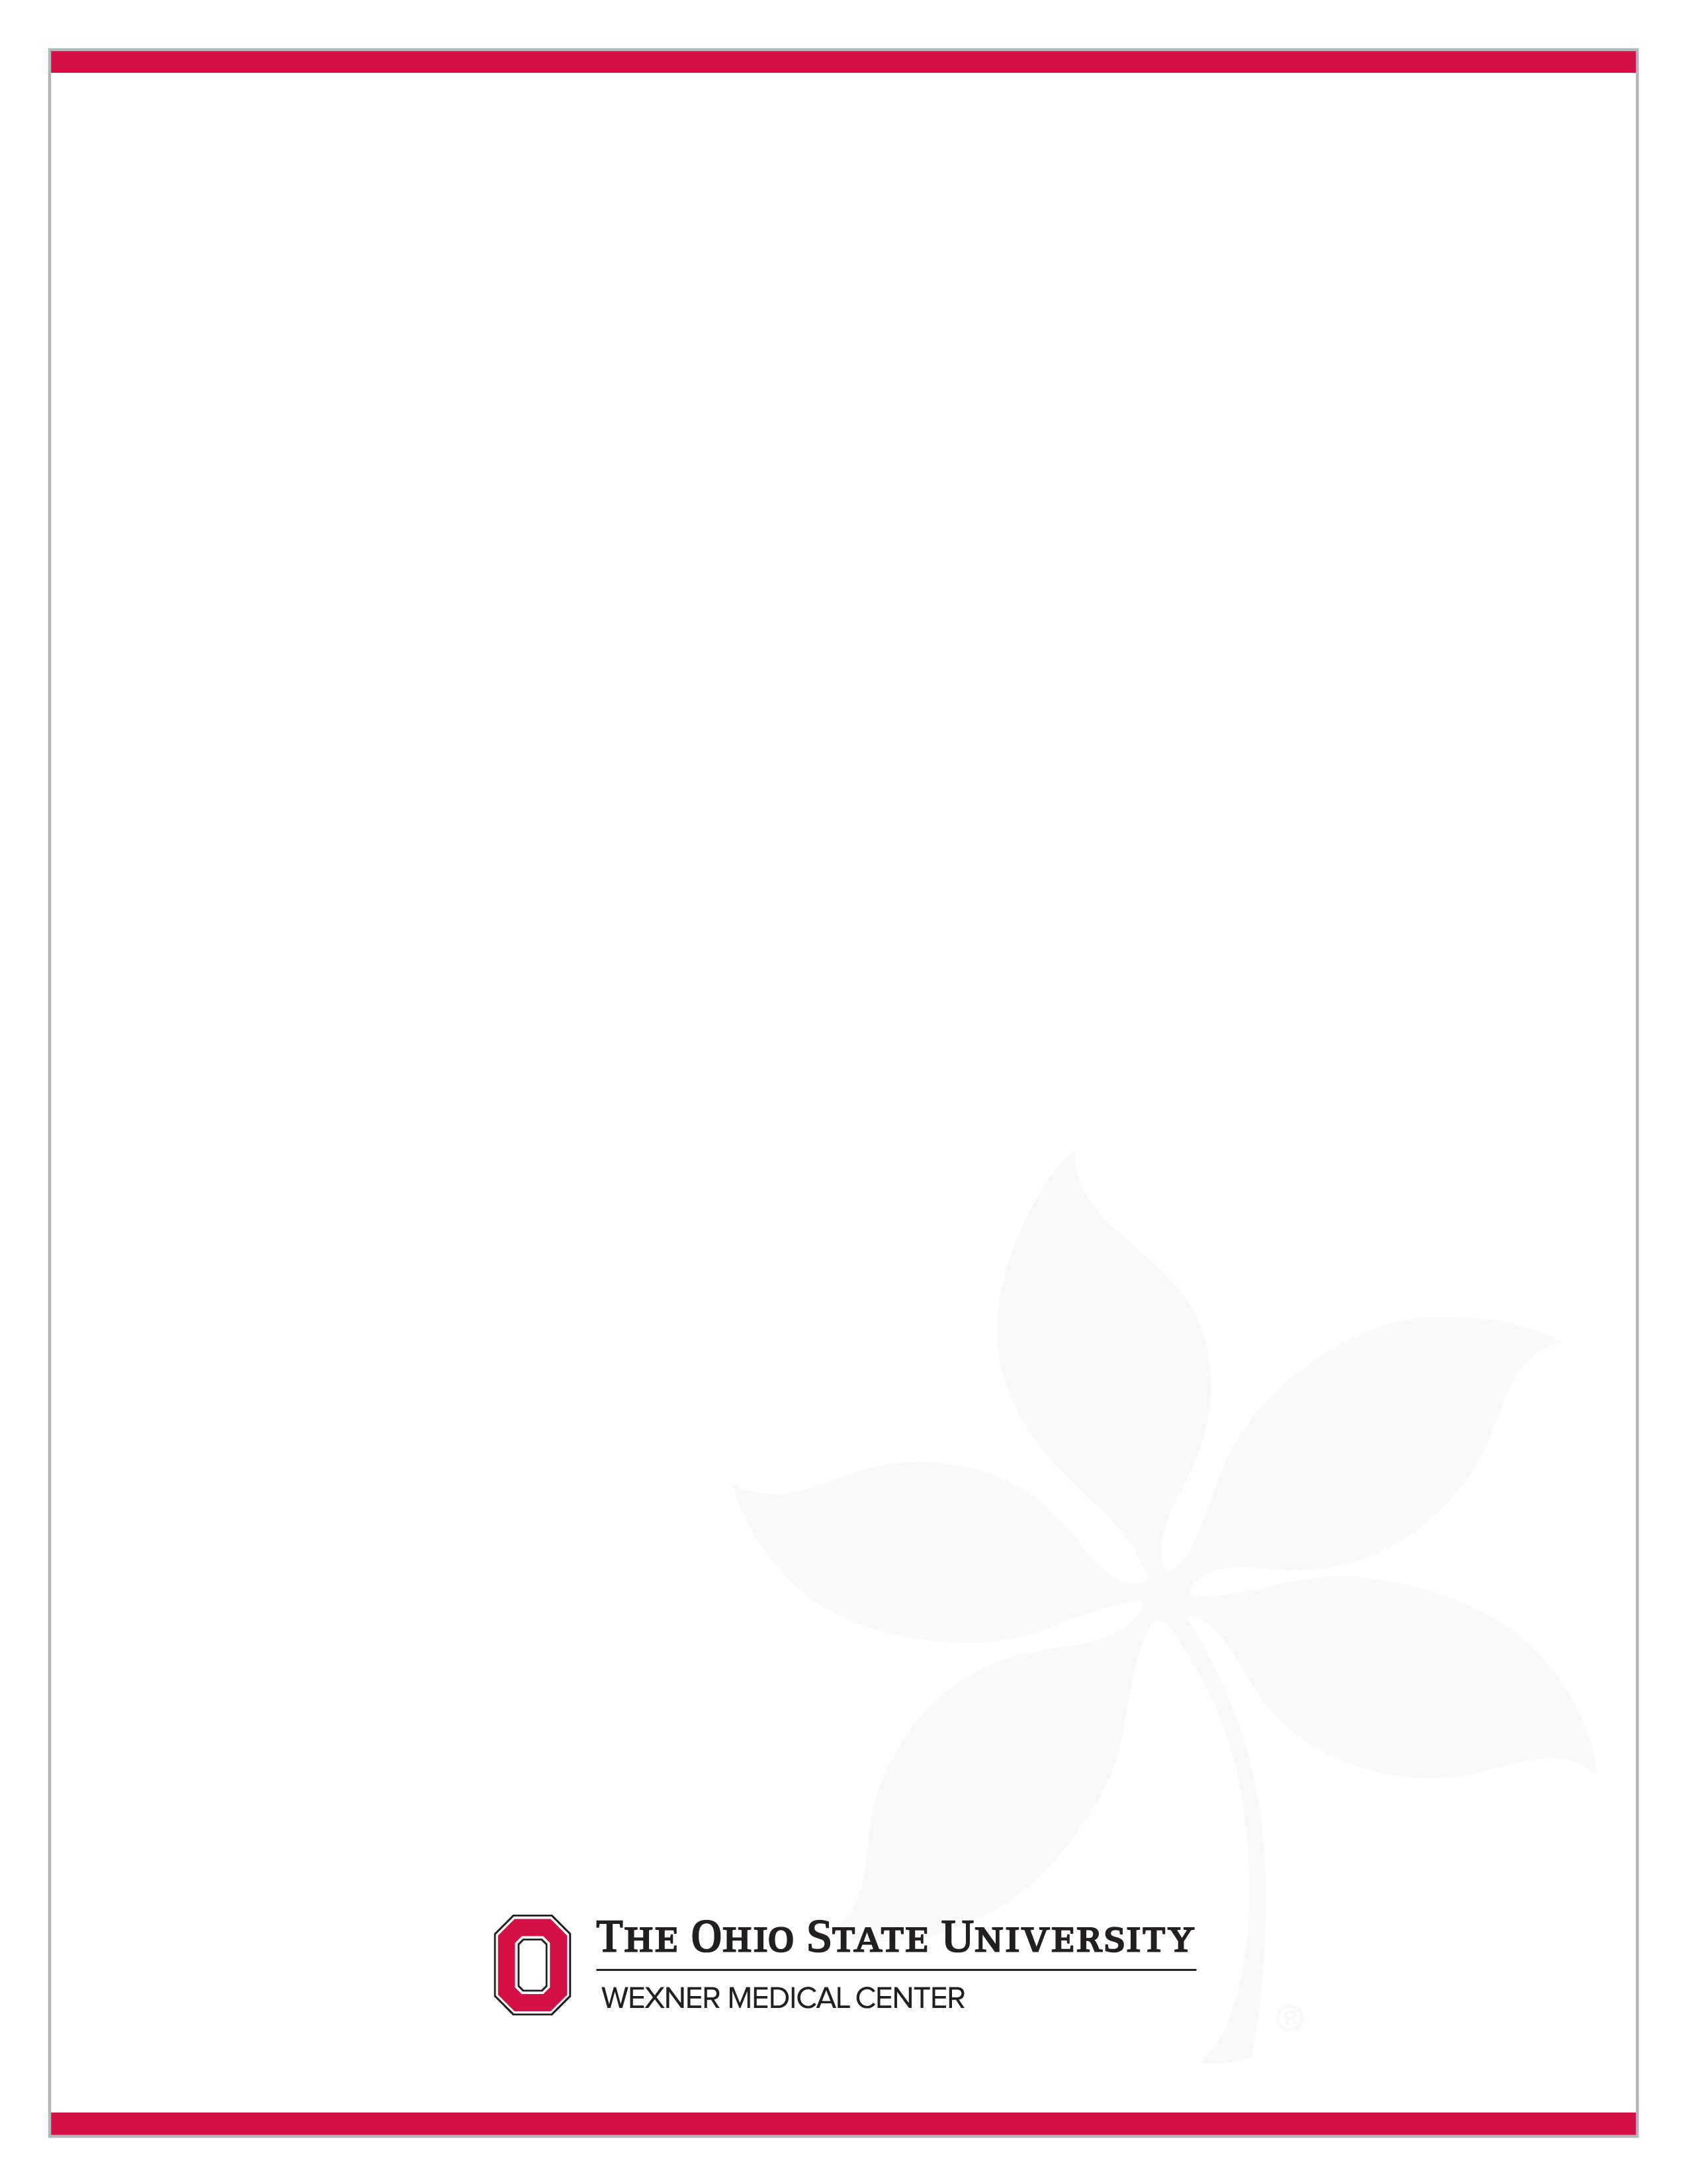
Study Short Name Subject Initials/Subject #

Questions or problems with the study please contact #### at #### or ####@osumc.edu.

All visits occur at #### address.
Please still drink plenty of water, but no food, when you arrive fasting for labs.

Visit | Visit Window | Scheduled Date | Time | Appt. Details
3-Week 16 | 06/07/19 -6/21/19 |  |  | 2-3 hours
4-Week 32 |  |  |  | FASTING VISIT Hold Morning dose until after blood draw
5-Week 48
6-Week 64 |  |  |  | FASTING VISIT Hold Morning dose until after blood draw
7-Week 80
8-Week 96 |  |  |  | FASTING VISIT Hold Morning dose until after blood draw
9-Follow-up

Study Medication Information:
- Take capsules whole do not open or chew. Missed doses can be taken if it is more than 6 hours before the next scheduled dose. If less than skip the dose.
- Please call us if you are having problems with the medication. Do not reduce or increase the dose if having difficulty. Talk with Dr. XXXX first.
- Must keep all study medication supplies even when the bottles are empty. Will bring back kits and all unused medication to follow-up visits and be dispensed new kits.
- If you miss a dose(s) please document it.
Other New medication or Changes
If you take any new medication or change existing medications I will need to know how long you took it, the name, dose, and the reason you took it.

